**Acknowledgement**

We would like to thank respected Mr. Santosh Dhungana for giving us such a wonderful opportunity to expand our knowledge for our own branch and giving us guidelines to present a report. It helped us a lot to realize of what we study for.

Secondly, we would like to thank our seniors who patiently helped us as we went through our work and helped to modify and eliminate some of the irrelevant or unnecessary stuffs.

Thirdly, we would like to thank our friends who helped us make my work more organized and well-stacked till the end. Next, we would like to thank WordPress for giving such a useful platform. It helped our work a lot to remain error-free.

**Abstract**

"In today's fiercely competitive business landscape, the ability to respond to customer needs effectively and promptly is paramount. With consumers increasingly seeking online access to products and services, establishing a strong online presence is indispensable.

Welcome to "MyDairy," your ultimate e-commerce destination for all things dairy-related. MyDairy is a dynamic web application dedicated to offering a diverse array of dairy products. This project empowers users to effortlessly browse, select, and purchase dairy items, complete with user-friendly payment options such as E-Sewa, Khalti, and Cash on Delivery. Furthermore, it provides administrators and managers with seamless access to oversee orders placed via both Pay Later and Instant Pay methods.

To bring MyDairy to life, a comprehensive understanding of various cutting-edge technologies is imperative. These technologies encompass a multi-tiered architecture, server and client-side scripting techniques, and the utilization of platforms like WordPress, complemented by the integration of relational databases. Our project's core objective is to create a user-centric website featuring a robust shopping cart application while also unraveling the technological components necessary for its realization.

This document will delve deep into each of the underlying technologies essential for the development and implementation of MyDairy, your trusted online destination for all your dairy product needs."

|  |  |
| --- | --- |
| Title | Page No. |
| Chapter 1: Introduction | 1 |
| 1.1 Project Introduction | 1 |
| 1.2 Problem of statement | 1 |
| 1.3 Objective of project | 1 |
| 1.4 Limitation of the project | 1 |
| Chapter 2: Requirement Analysis and Feasibility Analysis | 2 |
| 2.1 Existing systems overview | 2 |
| 2.2 System Development Model | 3 |
| 2.3 Requirement Analysis | 3 |
| 2.4 Feasibility Study | 6 |
| Chapter 3: System Design | 7 |
| 3.1 System architecture | 7 |
| 3.2 Database Design | 8 |
| 3.3 Process Design | 9 |
| Chapter 4: Implementation | 10 |
| 4.1 Tools used | 10 |
| 4.2 Testing | 10 |
| Chapter 5: Conclusion | 12 |
| Screenshots | 13 |

**Chapter 1:**

**Introduction**

1.1. Project Introduction

“MyDairy” is an ecommerce website which sells various kinds of milk products to the customer over the Internet. The payment gateway like E-Sewa implemented to aid the service of e-payment transactions.

1.2 Problem of Statement

In the context of the online market in Nepal it is hard to find ecommerce websites which only sells dairy products. The OTP service implemented in e-commerce sites are also prone to failure. Many low budget shops still lack their own online store. It also costs a huge budget to set up an advanced e-commerce site.

1.3 Objectives of the project

● To build an e-commerce site in a cheapest way

1.4 Limitation of the project

● eSewa is used for payment gateway

● Locally hosted

**Chapter 2:**

**Requirement Analysis and Feasibility Analysis**

2.1 Existing Systems Overview

The following existing systems are studied for the project:

1. Daraz

Daraz is the most popular online marketplace and is growing rapidly in Asia’s marketplace creating best shopping experiences to customers of Bangladesh, Myanmar, Pakistan, Sri Lanka and Nepal. Kaymu.com.np united with Daraz and now it is one store in the name of Daraz.com.np and they make a platform to connect its sellers and buyers. They update their online store as per the running trend of a new product. In the current scenario, it stands out to be the largest and most popular online shopping destination in Nepal. Daraz shares a mixture of consumer fashion (clothing, footwear, accessories and beauty products), electronics, mobile phones, laptops etc. It gives privileges to shoppers by providing them with security, value of the product by selling good quality products and delivering those in time with easy returns.

2. Sastodeal

SastoDeal is one of Nepal’s biggest and leading online shopping websites which provides services in and around the valley. This online company has the vision to empower both customers and vendors for ultimate online shopping and merchandising experience. They have a motto to keep trust with customers so they make their business transparent and provide quality products. This company deals with Women and Men clothing, footwear, Bags and Wallets, Jewellery etc. And also features products related to home and living, Health and fitness, Auto, Pet Supplies, Activities, Grocery and Crockery, Sastobook. Delivery rates are divided according to inside ring-road, outside-ring road, beyond Kathmandu valley.

2.2 System Development Model

We know all the requirements for this project and they are clear. There are no stakeholders and users to bring out changes to the system repeatedly. So, a waterfall model is preferred in this project.

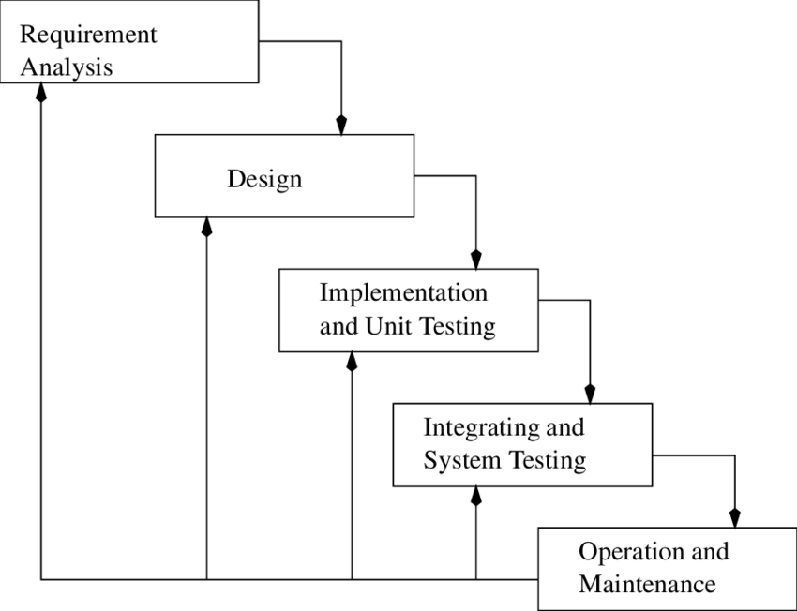

Fig: Waterfall model

2.3 Requirement Analysis

2.3.1 Functional Requirements

In order to make the website functional, we require the following

1. User Registration:

The user can register through the register page. The user must provide email, mobile number, etc.

1. User login:

Given that a user has registered, then the user can log in the website

through his/her username and password. The login information will be stored

in the browser and in the future the user will be logged in automatically.

1. Home activity:

The first page that is shown should be the home activity. The user gets

references to all other activities like all products, my account, cart,

etc.

1. Item search:

The user can search his/her choice of product by typing the name. The

project will appear if others show no results.

1. Product details:

The user can get the details of the product search by clicking on the

product such as price, date, etc.

1. Purchase product:

Given that the user is logged in, the user can purchase the product or add

it into the cart.

1. User profile:

Given that the user is logged in, the user can look at his/her profile

information.

1. Logout:

Given that the user is logged in, the user can log out of his/ her account

when they are done surfing.

1. Cart:

Users should be able to add different products to cart and see the price.

1. Payment:

Users should be able to pay with different options whichever they prefer.

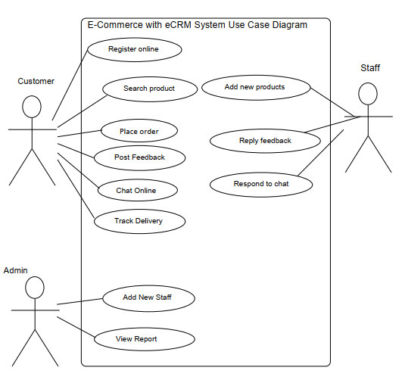

Fig: Use Case diagram for the website

2.3.2 Non-functional Requirements

The non-functional requirements of this website are as follows:

i) Good Performance:

For the response time, the website has less than 15 seconds if the user has a proper internet connection and for the fault tolerance, if the system loses internet connection or the systems get strange inputs, the user is informed.

ii) Maintainability:

The website is easy to extend. It is developed in a way that it favors implementation of new functions. Similarly, the website is reliable and gives the correct results. The website is available 24 hours for the user to use.

iii) Secure:

There is security of the communication between the user and webserver using SSL. Only authenticated users are allowed to view their respective databases. The security of creating account for the user is maintained. No two users with the same email and phone number are created.

iv) Easy user interface:

The user interface is light and easy to use. The functionality is easy to understand. The theme and color of the website is eye pleasing. The user is informed correctly if he/she is doing anything wrong.

2.4 Feasibility Study

For the technical aspects, this website is feasible. The software and hardware requirements for the development of this website are not many and are already available as free as open source. The work for this project is done with the current equipment and existing software technology. This website is supported by all types of browsers.

Similarly, from operational view too, feasible because this website solves the problem faced by the user while searching and choosing a product. Through this website users can check the order details and the items purchased through their profile.

This project is easily economically feasible because it was made in a free and open-source platform and hosted locally too in my own device.

The schedule was properly managed by me too as it took me a few weeks to make this site.

**Chapter:3**

**System Design**

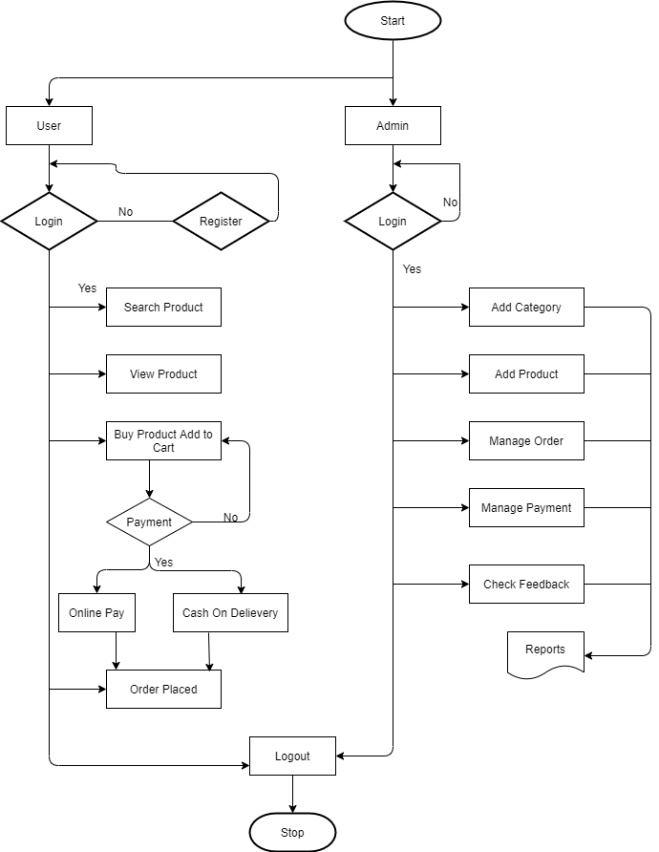3.1 System Architecture

Fig: Architecture of the whole system

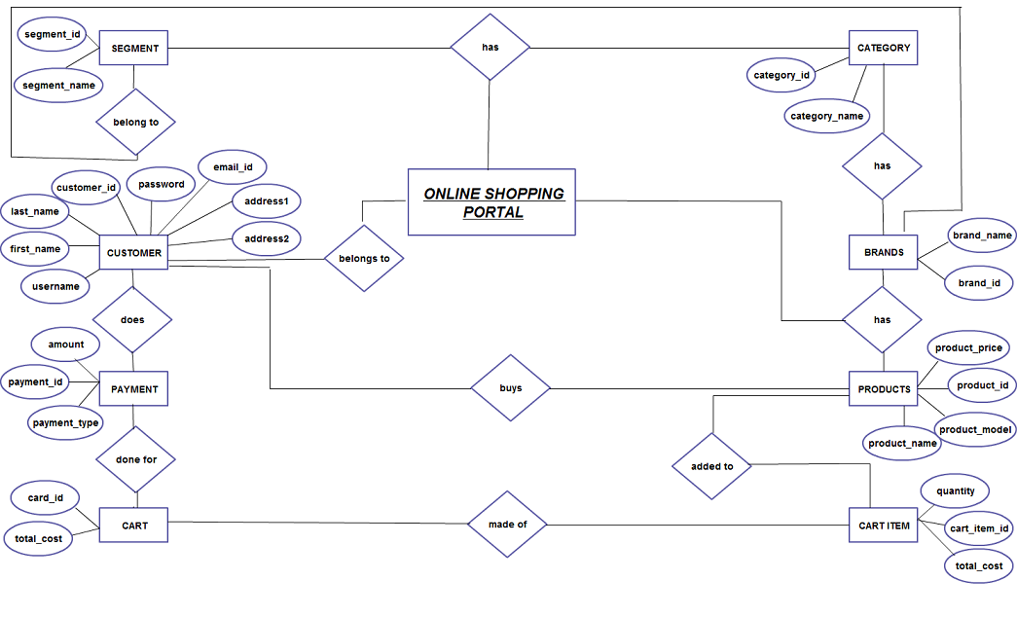3.2 Database Design

Fig: ER diagram for the e-commerce site

3.3 Process Design

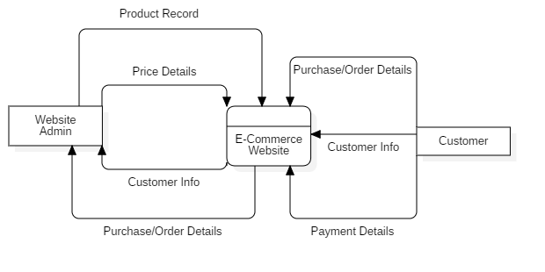

Fig: Level 0 Data Flow Diagram (DFD)

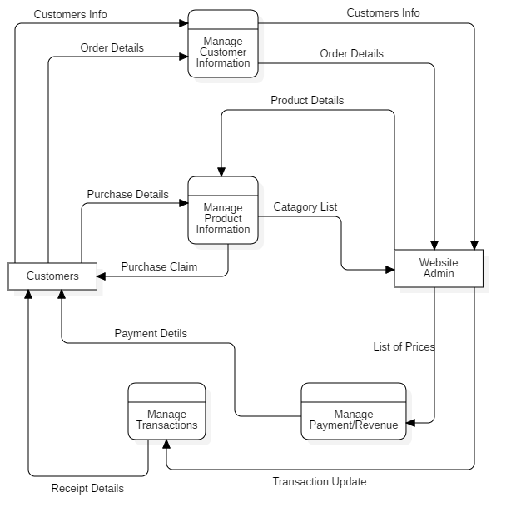

Fig: Level 1 Data Flow Diagram (DFD)

**Chapter 4:**

**Implementation**

**4.1** Tools Used

* WordPress – It was used to make e-commerce website.
* Draw.io – It was used to make ER diagrams, System flow chart

**4.2** Testing

**4.2.1** Unit Testing

**Test for Registration**

|  |  |  |  |
| --- | --- | --- | --- |
| Test description | Expected Result | Actual Result | Remarks |
| Enter invalid mail address and invalid phone number | Display error message | Displayed error message | Pass |
| Enter valid mail address but invalid phone number | Display error message | Displayed error message | Pass |
| Enter valid mail address and valid phone number | Send OTP to the phone number | OTP sent to the phone number | Pass |

**4.2.2** Integration Testing

|  |  |  |  |
| --- | --- | --- | --- |
| Test description | Expected Result | Actual Result | Remarks |
| After registration login is done with email address | Show the dashboard of the user | Showed the dashboard of the user | Pass |

**4.2.3** System Testing

|  |  |  |  |
| --- | --- | --- | --- |
| Test description | Expected Result | Actual Result | Remarks |
| After registration login is done with email address | Show the dashboard of the user | Showed the dashboard of the user | Pass |

**Chapter 5:**

**Conclusion**

This project explores how an e-commerce site works and operates. It has different features like login, cart features, different payment options, categories of projects, review section and so on. It has search features too for the ease of use of the customers. It has good interface and feels easy to use. The response time is good too. So, a whole e-commerce site was created.

**Screenshots**

